TABLE OF CONTENTS:

1. **Perform, Conduct, Evidence and Document Strategy Plane Research.**
2. **Apply UX Principals and Data to Scope Plane Outline.**
3. **Create Application Structure and Information Architecture for Structure Phase.**
4. **Wireframe Implementation for Skeleton Plane.**
5. **Implementing UI Prototypes, Styles guides and Branding for the Surface Plane.**
6. **Conclusion and Recommendations.**
7. **References**

**1. Perform, Conduct, Evidence and Document Strategy Plane Research.**

Research interviews may be conducted in a variety of ways, each of which has its own advantages and disadvantages.

* **Interviews with Individuals:**

A common sort of interview is a one-on-one interview, in which the interviewer asks questions directly to the responder. Using an online survey guide, a researcher may jot down the responses to questions. It is possible to organise a poll in such a manner that the interviewer's remarks or viewpoints stand out.

* **Interviews by telephone:**

In order to do research, telephonic interviews are extensively employed and may easily be combined with internet surveys.

* **Interviews over e-mail or on a website:**

Increasing numbers of people are doing research online, and it's in everyone's best interest to keep up with this trend.

Interviews conducted by email or a web page have become more common due to the growing number of individuals who have access to the Internet. There is no better tool for this purpose than a poll conducted online.

Online shopping is becoming more popular, which makes it an excellent target market for conducting interviews that provide useful data for making informed purchasing decisions.

**Interview questionnaire:**

1. What's going through your mind while you gaze at this?
2. When you first saw this product or feature, what was your initial impression?
3. What do you believe this product or feature accomplishes or will accomplish?
4. How do you get started?
5. Where and when do you believe this product/feature would be most useful?
6. When you use this product, what do you want to accomplish with it?
7. If you didn't use it, what would be the reason?
8. Do you see any similarities between this product and another?
9. Do you have confidence in this product?
10. Has this design made you feel as though it was developed just for you? Is there a reason for this or not?
11. What was the most appealing aspect of the design to you?
12. What was the design flaw that bothered you the most?
13. What would you change about the design if you could?
14. If the changes were implemented, would you download or use this product?
15. Do you think this is appropriate for use on a laptop or desktop computer? Mobile? Is it possible to have both?
16. What would you tell a friend or family member about this?

**PERSONA OF THE USERS:**

**Persona for the website development company:**

Rohit, a harried owner of a small business

**Demographic**

Male

30 years of age and counting

Single

The manager of a small company.

$50,000/year

Highly competent, tenacious, and focused on the bottom line

**Bio**

Since he was a child, Rohit has aspired to be his own boss. Rebranding is on the agenda for him after seven years in the industry. Get a new webpage for his firm is the first item on his to-do list. Rohit is seeking for a website provider that can get the job done quickly since he spends much of his spare time working on his business.

You may expect updates from him at every step of the design process. While his friends advise him to take a break from work, the entrepreneur believes that productivity is the only way for him to succeed in business.

**Goals**

Create a website where his goods may be shown.

Improve the quality of your work-life balance.

Hire the first person he knows.

**Motivations**

For new product images, a basic CMS is needed.

The ability to provide his consumers with an enjoyable online purchasing experience

Optimized responsiveness for mobile devices

**Frustrations**

Unsatisfactory level of client service

Due to inefficient procedures, he often runs late for appointments.

His website has pixelated photos.

**Brands**

Etsy

Wix

eBay

**Channels of choice**

Instagram

Facebook

LinkedIn

**Persona for a Retail Store**

Alexa Walters is a sassy and stylish Generation Z shopper.

**Demographic**

15-year-old female

Single Student

Save money on babysitter fees.

Educated about current fashion trends and friendly

**Bio**

Alexa is widely considered to be one of the most fashionable students in her class. She works as a babysitter once a week and saves some of her money for college, but she spends the rest of it right away. Shopping with friends, attending art galleries, and publishing her looks on Instagram are some of her favourite pastimes. As a way to spread the word about her passion for fashion, she intends to launch her own blog.

Alexa plans to go to design school after high school and is taking as many art courses as she can. She plans to begin looking for work in retail when she gets sixteen.

**Goals**

Get 10k Instagram followers.

Partner with businesses for her fashion blog.

Show her peers her creative side.

Motivating factors include convenient internet purchasing and stores with an Instagram presence.

Out-of-stock items—especially if they aren't available online or at the store—are a common source of frustration for her

**Preferred channels**

Instagram

YouTube

Text messaging.

**Brands include**

Urban Outfitters

Poshmark

Madewell.

**2. Apply UX Principals and Data to Scope Plane Outline**

## **UX mapping methods**

UX design uses a variety of mapping strategies in order to generate a shared understanding of the aims and expected results of the design and development teams working on a given project.

There are four basic forms of mapping used by UX designers, each with its own set of techniques and objectives. The purpose of these techniques is to visualize and better understand the user experience in order to discover and fix pain spots via a product team's designs.

Empathy mapping, experience mapping, customer journey mapping, and service design (blueprint) mapping are all examples of mapping.

While we're on the subject of experience mapping, it's useful to know about the other two:

* An empathy map helps team members comprehend a user's thinking; these maps concentrate and graphically reflect what users say, think, do, or feel. • We as UX designers can better express what we know about a certain kind of user so that we can make better design decisions as a team.
* Customer journey maps, by contrast, concentrate on the user's path through the product or service in order to achieve a certain objective, and are therefore more comprehensive.
* Service design (blueprint) maps reflect the perspective of workers. It aims to assist enterprises in providing the greatest possible experience for their workers.

On the other hand, an experience map is focused on a specific aim and a high-level knowledge of human behaviour. Product and service agnostic is the primary attribute of an experience map. It lets you get a sense of the present state of affairs without having to consider your product yet.

An empathy map is often used to get an understanding of the user's perspective before moving on to other maps, such as a journey map or a user journey map. An experience map is then created when we have a better grasp of our users. It's here that we concentrate on human behaviour at a high level to have a basic knowledge of our user's experience without our product. The customer journey map is often the next step in the process. The emphasis of a customer journey map has shifted to the precise experience your product or service provides customers as they go through their journey.

It's time for the last sort of mapping: a service design plan, which focuses on the employee experience. A service design blueprint aids your business in identifying areas for improvement inside your own organization in order to better serve your customers.

**3. Application Structure and Information Architecture for Structure Phase & Apply UX Principals and Data to Scope Plane Outline**

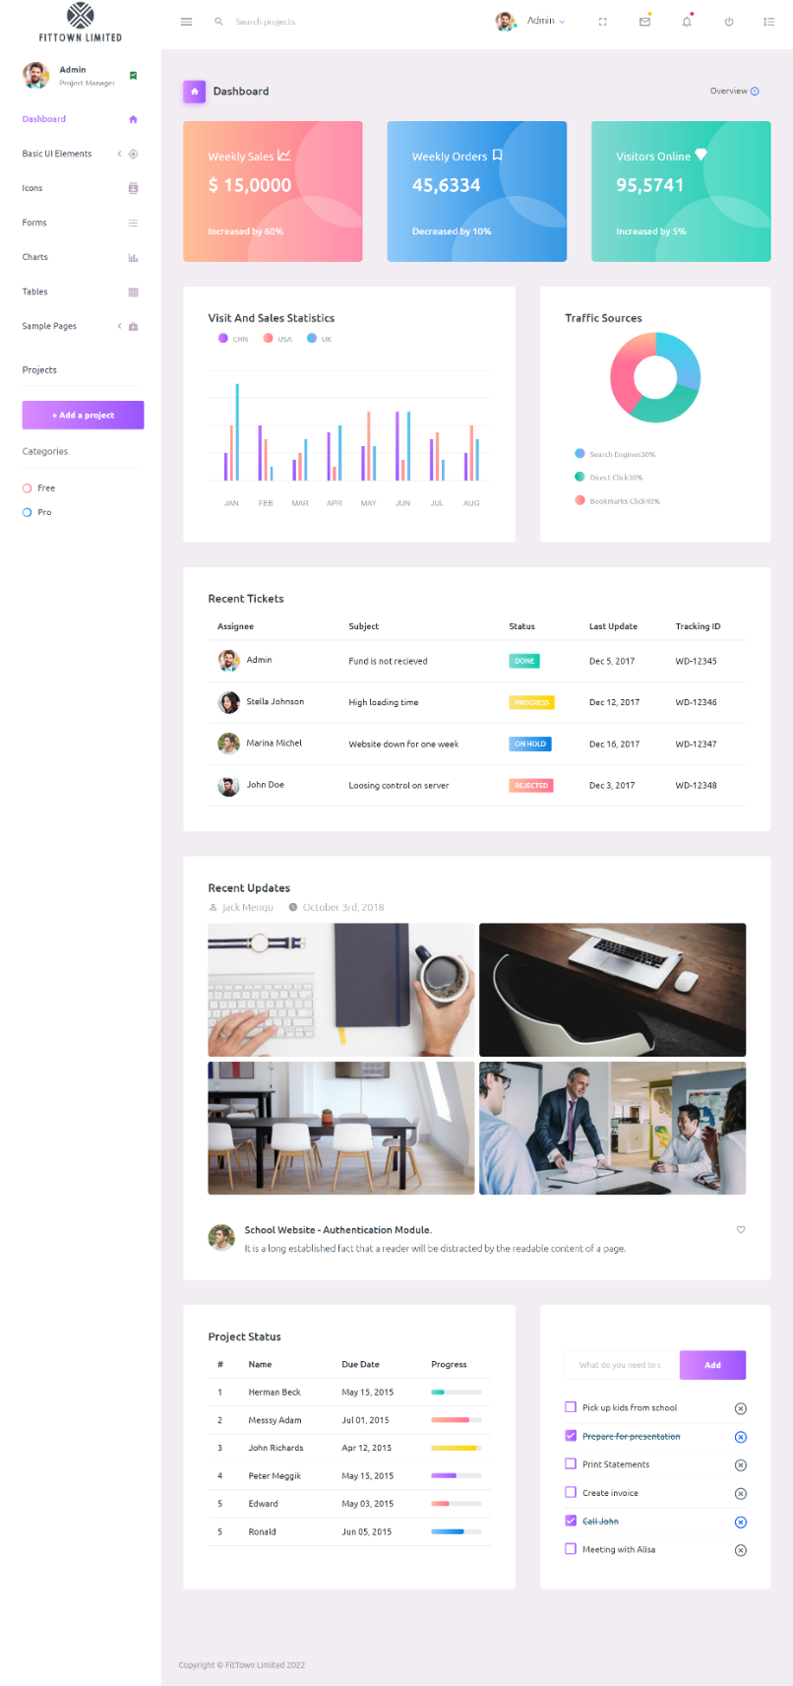

Admin Customers Orders Management

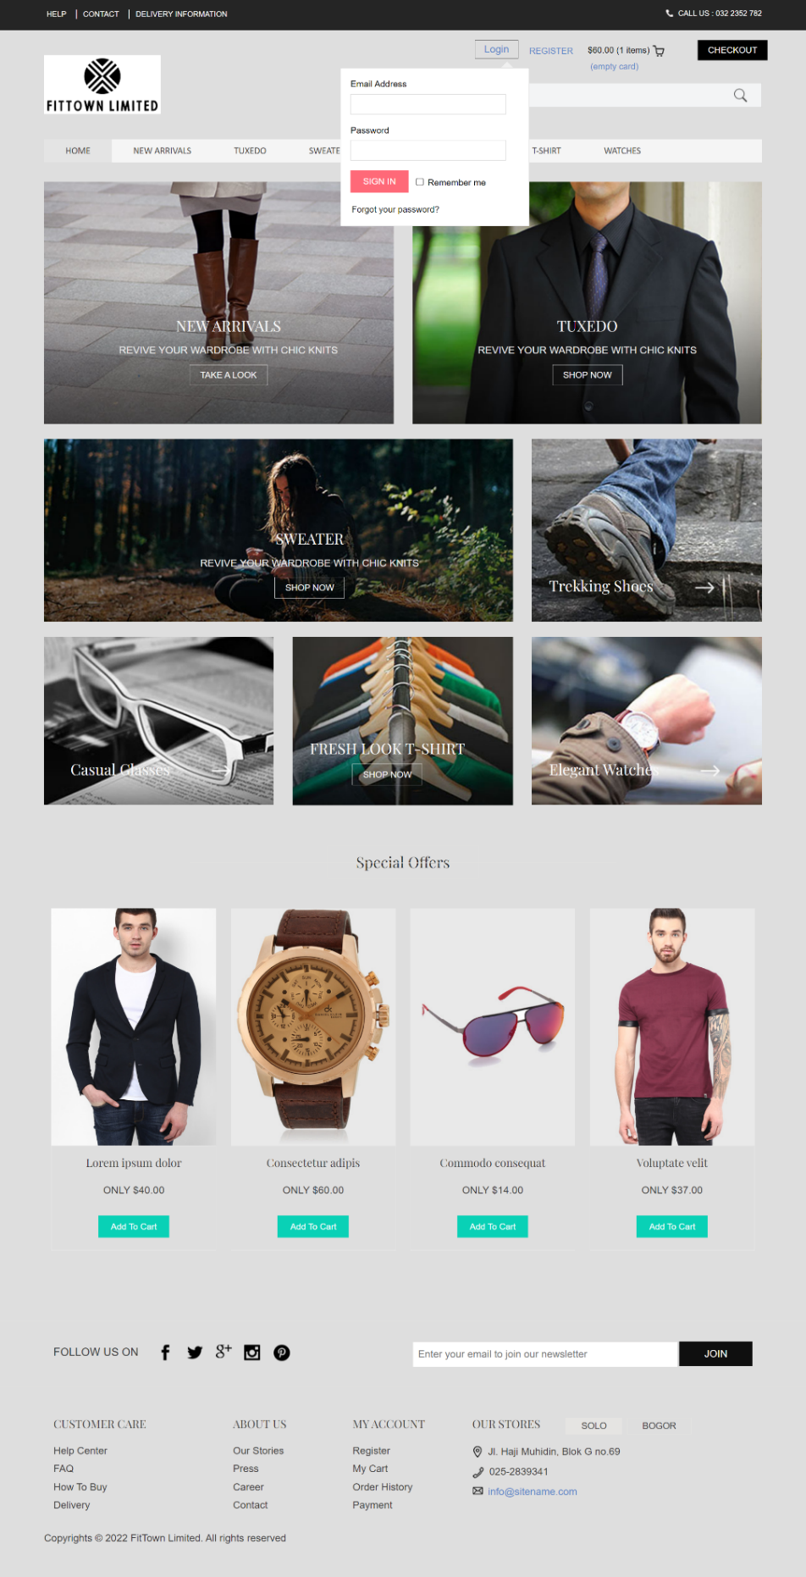

Customer Login

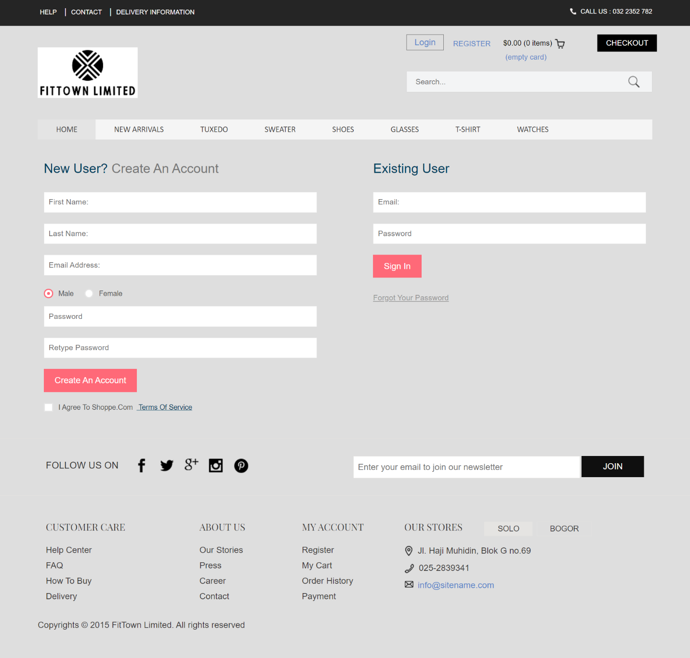

Customer Signup

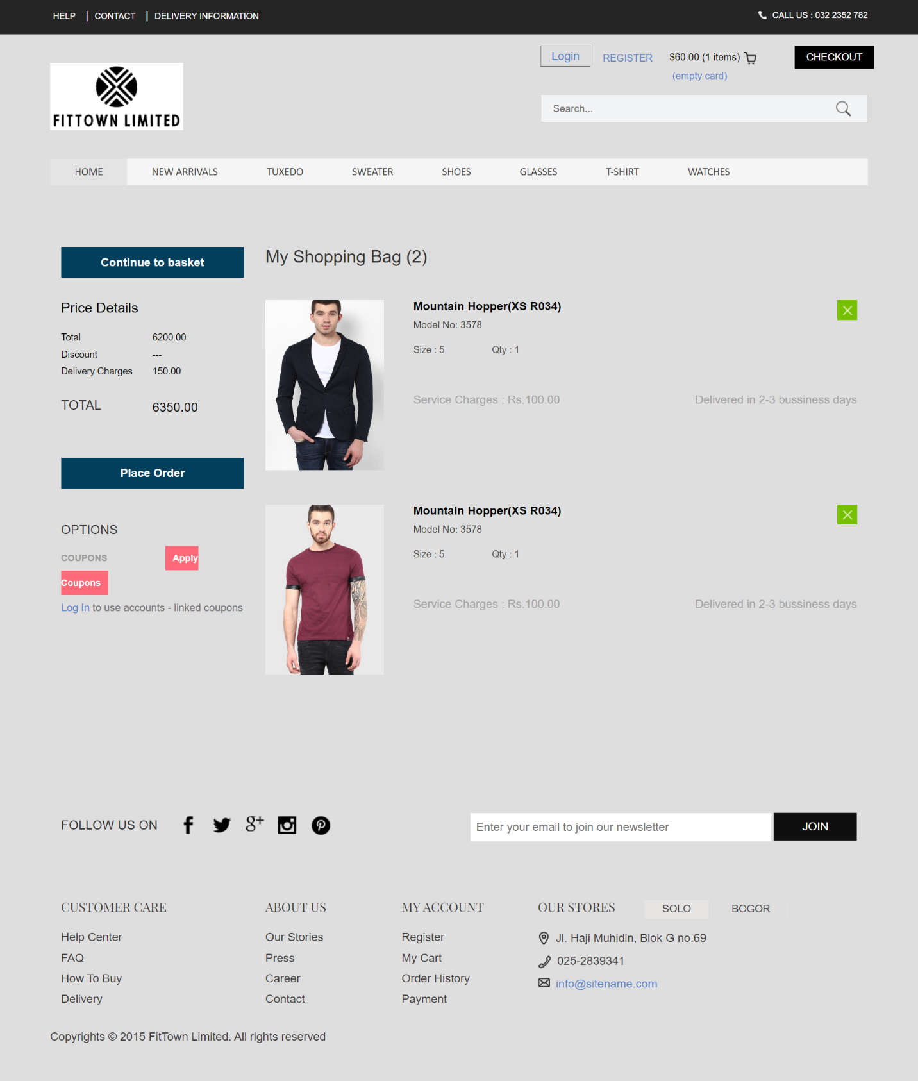

Customers add to cart option

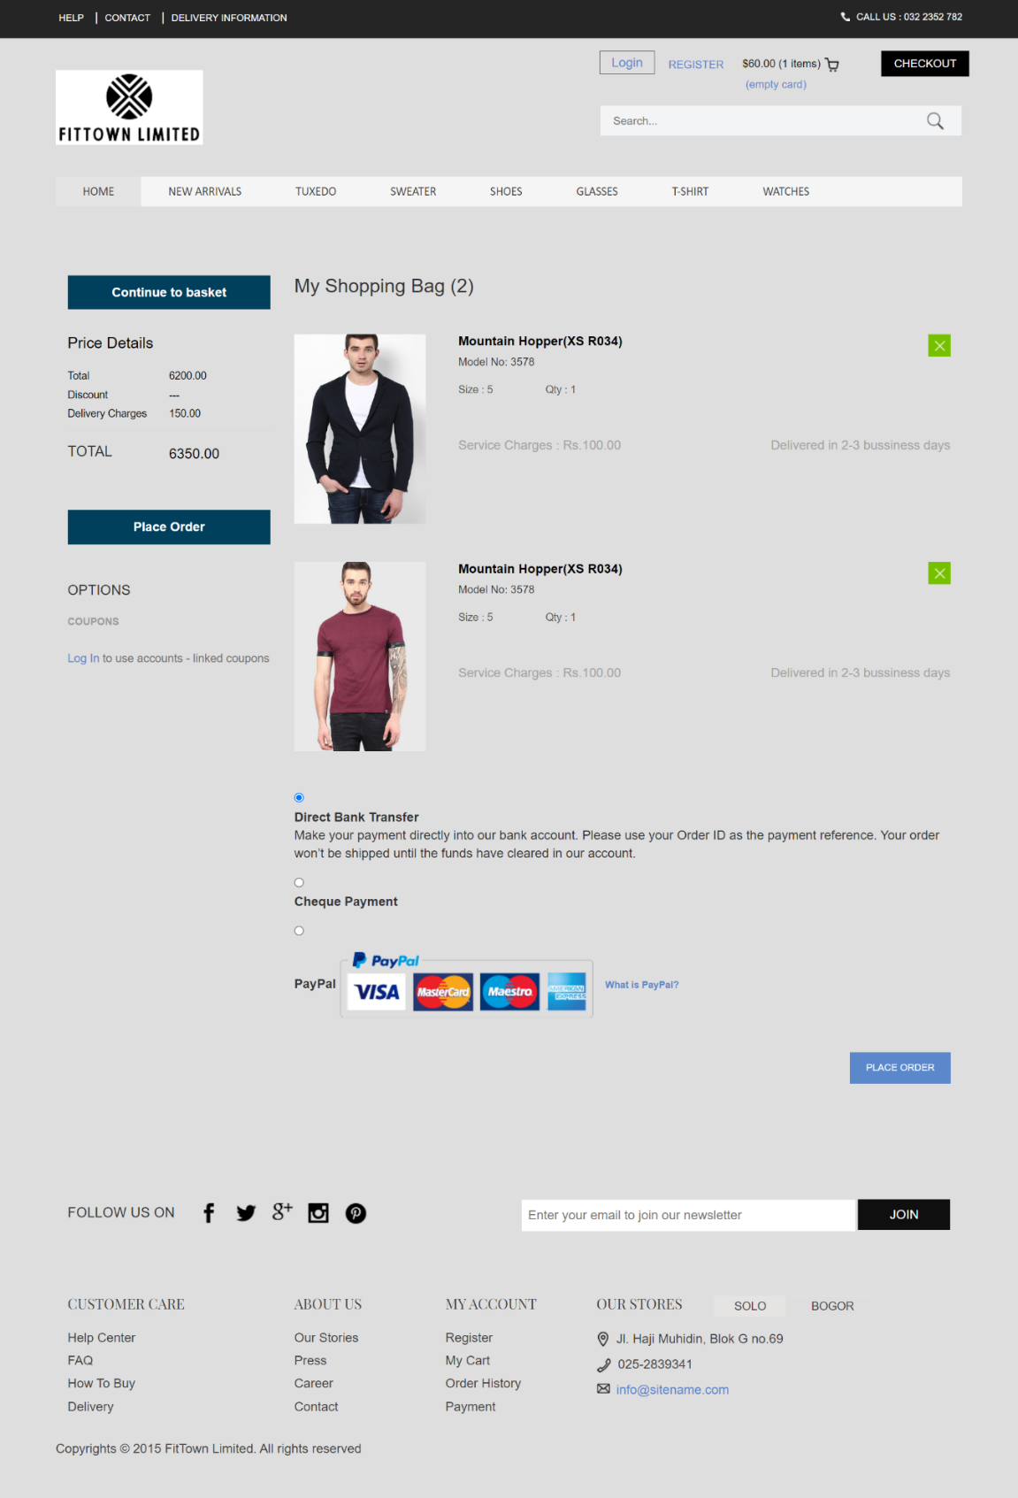

Customers Paypal Payments

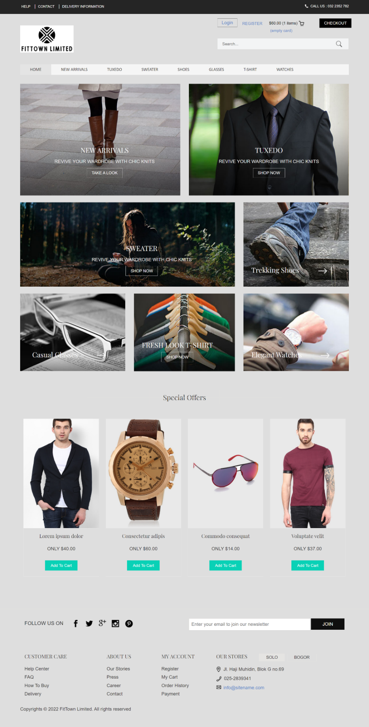

Customers Search

**Wireframe Implementation for Skeleton Plane**

* Stakeholders will benefit from better communication.

Customers must provide designers and developers with specific input in order for them to build a successful product. However, even for internal stakeholders, low-fidelity wireframes might seem abstract. Using high-fidelity wireframes makes evaluating a product's overall design and user experience (UX) considerably simpler.

* More accurate results from testing

A high-fidelity wireframe template may assist your team in creating a realistic prototype for the purpose of gathering first input from users. Users respond more quickly to dynamic, hi-fi wireframes, according to research, and this leads to more accurate and useful input for future products.

* With high-quality wireframe templates, you'll save time and money.

Your design process may be accelerated and time saved by using a ready-to-use high quality wireframe template

For the best user experience, however, our product is as easy to use as feasible. User testing prototypes and wireframes is the best way to attain this goal.

Let's have a look at a copy. If you're utilizing placeholder text like Lorem Ipsum (or a Lorem Ipsum variant) because your content isn't fully created, you'll want to determine the absolute minimum quantity of copy that's required. Your users will be able to navigate your wireframes and prototypes more easily this way.

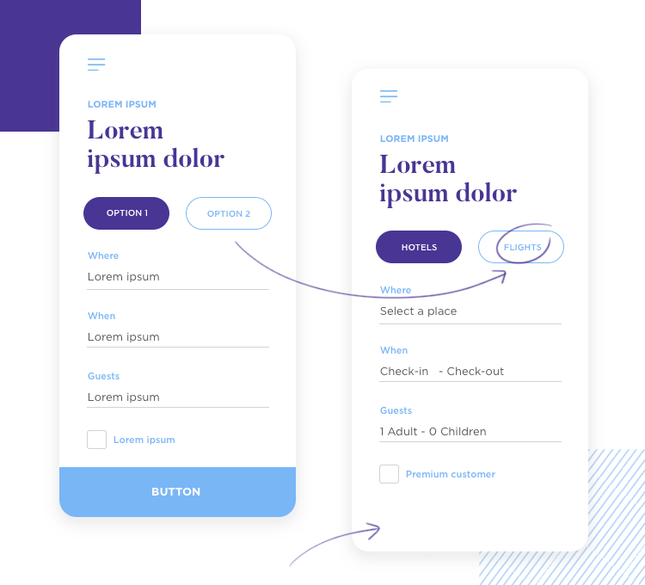

Additionally, make sure that the content used for crucial features like inline form validation is clear and understandable to users. The absence of interactivity and colour palette should also be taken into consideration when doing user testing on a wireframe.

The following are the major pillars of a usability test, with these concerns in mind:

Examples of participants, instructions, and observers

**Typical Clients**

A sample user is the group of people who will be testing your wireframes and prototypes for your target audience. User personas are a powerful tool for establishing a core group of consumers for your product. Use a user testing tool that automatically recruits sample people depending on the kind of product you're producing as an additional method of gathering feedback.

**Instructions**

In user testing prototypes and wireframes, well-thought-out instructions are essential.

If your users have previously participated in comparable sessions, explain to them that they are still working with a prototype or wireframe. The second thing to do is to make it obvious that you are testing the wireframe or prototype, and not the person using it.

**Moderator**

Securing comments from users and clarifying any instructions are made easier with the assistance of an expert moderator. A skilled moderator has a deep understanding of the routines and behaviours of the users, provides clear instructions, and is able to properly guide the users through the whole process.

Then then, you may conduct user testing of prototypes without the assistance of a moderator as well. Doing so will save you both time and money. It also gives you the flexibility to test at any time and from any place. Your users will, however, need to be given explicit directions on how to proceed.

**Observers**

When doing user testing on prototypes or wireframes, why is it necessary to include observers? It's possible that your moderator is already busy ensuring that the whole testing procedure passes without a hitch.

**Implementing UI Prototypes, Styles guides and Branding for the Surface Plane**



Above screenshot attached is designed in way with all the branding concepts which includes the brand strategy, the user experience with the branding, brand experience with the user’s experience design, engaging user creativity all lie down the branding of the above UI designed as seen in screen shot as well.

**Conclusion:**

Making a web that is usable and accessible by everybody is a complex process that involves balancing a number of different considerations. Their objectives, methods, and guidelines are quite similar. When it comes to creating websites and software, it's best to tackle these issues all at once.

There are a few instances in which it's critical to narrow your attention to a single topic. For instance, while formulating guidelines and regulations. Researching the accessibility requirements of individuals with impairments aids in the development of those.

Accessibility includes:

* In contrast to aesthetic criteria, technical requirements focus on the functionality of the underlying code. Examples include ensuring accessibility for those using assistive devices. Screen readers and magnifiers are two examples of assistive technologies that fall under this category. Another kind of assistive technology is the use of voice recognition software to enter text. Research and practice in the field of usability seldom address these issues.
* Requirements relating to user interaction and visual design. People with impairments may face substantial obstacles as a result of poor design. They are included for this reason. Good usability includes, for example, clear instructions and feedback for online forms and applications. Cognitive and learning difficulties might also benefit from their services. A lack of accessibility guidelines might prevent certain persons with impairments from using the Internet.

The terms "accessibility" and "usability" have a lot in common. The "extent to which a product may be used by specified users to accomplish stated objectives effectively, efficiently, and with pleasure in a given context of usage" is usability.

As long as "specified users" covers persons with a wide variety of impairments, and "specified context of usage" incorporates accessibility concerns such as assistive technology, this might alleviate accessibility issues.

However, usability research and practice frequently overlook the demands of those with impairments.

**REFERENCES:**

Lookback.io. 2017. Lookback: Simple and powerful user research. [online].

Nielsen Norman Group. 2017. Checklist for Planning Usability Studies. [online]